Website Inspected: <https://www.geeksforgeeks.org/html-adding-youtube-videos/>

Metadata

* It is found in the head section.
* Provides metadata about the HTML document
* Ex: documents author, keywords, description, viewport settings

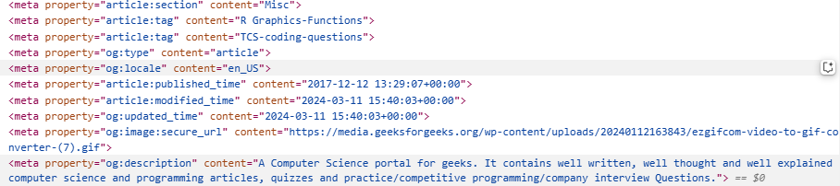

Headings and semantic elements

* The HTML tags used for headings are <h1> to <h6>. <h1> is the largest and <h6> is the tiniest.
* Semantic elements are used to provide meaning to the page structure to improve accessibility.
* Some common semantic elements are <header>, <footer>, <section>, <nav>

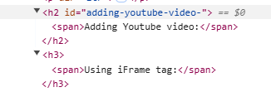

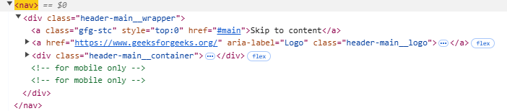



Multimedia

* The HTML tags like <audio>, <video> and <iframe> are used for multimedia content on the HTML document



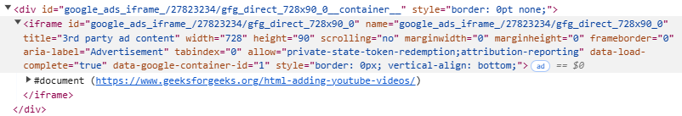

Security Relevant tags:

* CSP: The meta tag or HTTP headers can specify a CSP to restrict the types of content the browser can load
* Sandboxed iframes: An iframe with a sandbox attribute can add extra restrictions to the content it embeds preventing actions like form submissions and popups.

